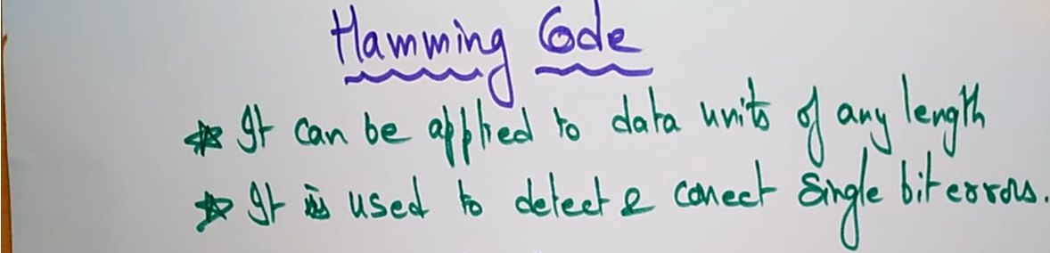  
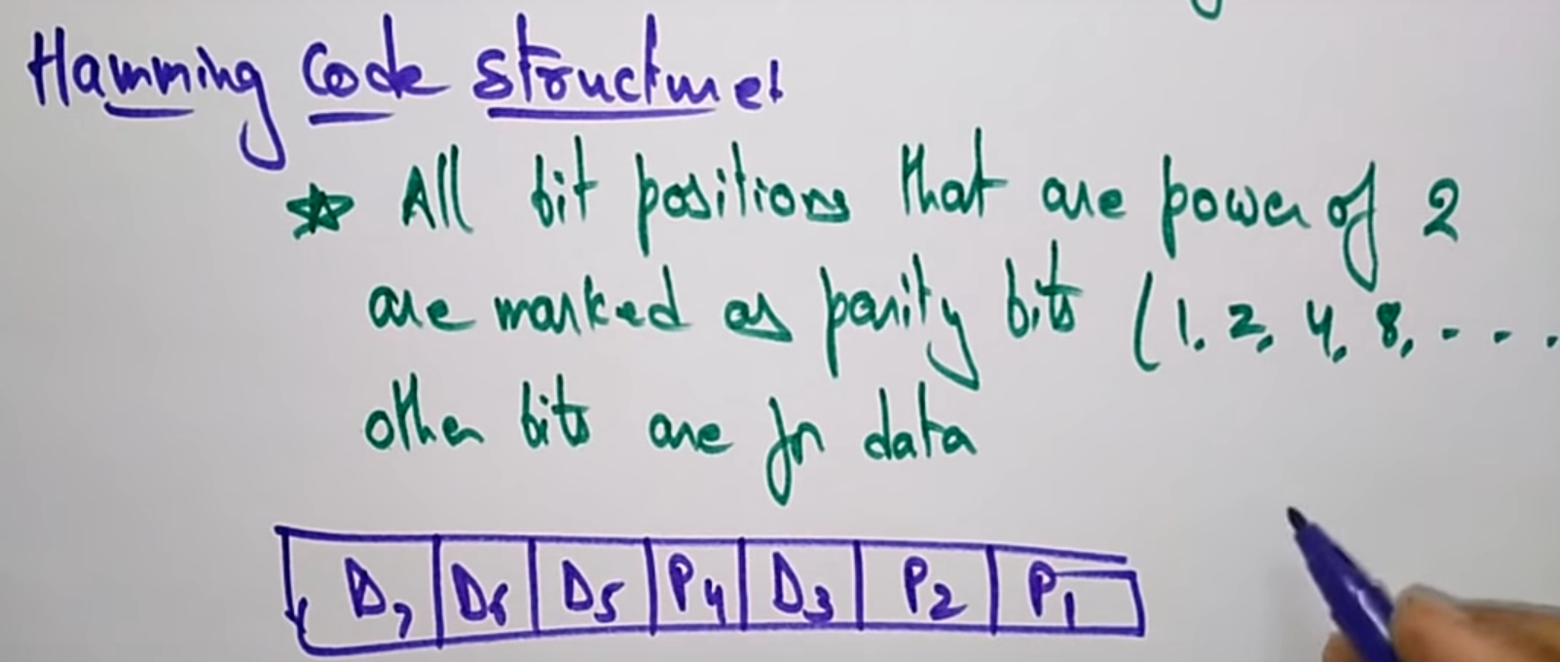

Sender side  
Determining the value of parity bit

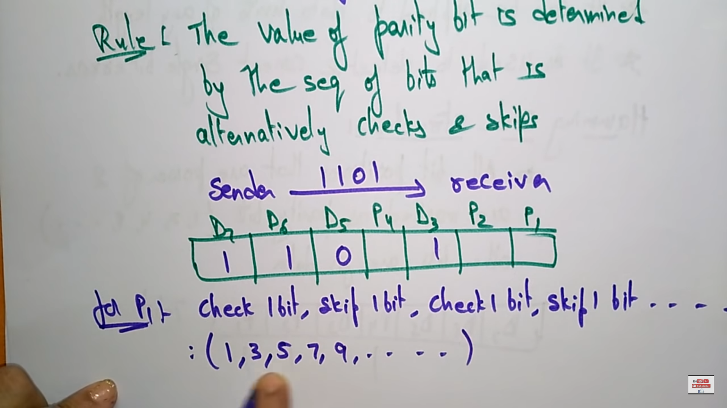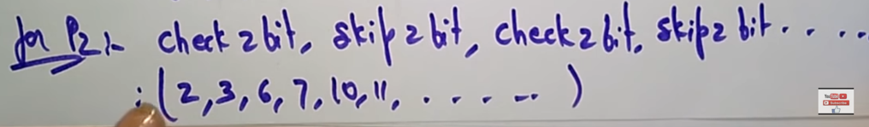

Start with 2,3 🡪 Check 2,3 skip 4,5 bits. Check 6,7 skip 8,9 bits.

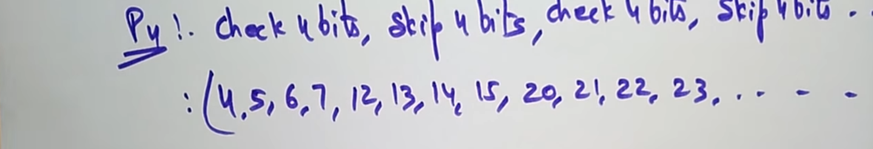  
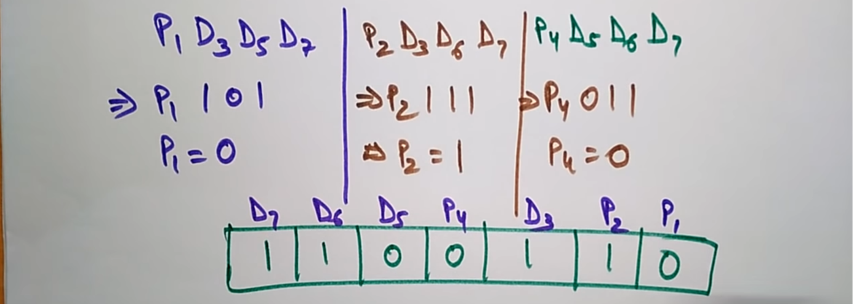

Decoding the above in the receiver side